FOR IMMEDIATE RELEASE
September 10, 2018

Contact: Michele Lee Evans Company: M.L.E Enterprises
Company Phone: (800) 979-5510
Cell Phone: (859) 979-2161
Email: info@mle-enterprises.com
Website: www.mle-enterprises.com

On sale October 15, 2018
Pages: 324
$20.00 Paperback
ISBN:
Evans - 13: 978-1725165236
Jewell - 13: 978-1725557208
Conley - 13: 978-1725557253
Ener - 13: 978-1725557321
Hansen - 13: 978-1725557444
Glover - 13: 978-1725557390
Bateman - 13: 978-1725557352

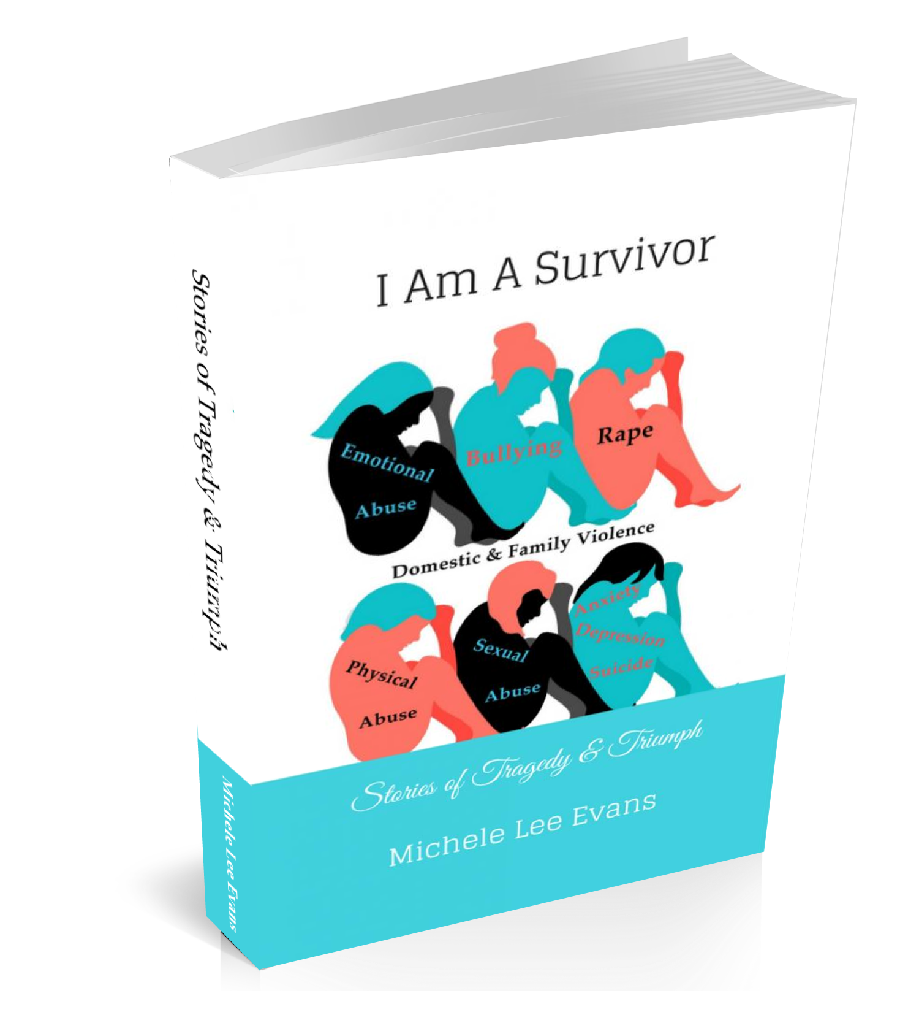
Official I AM A SURVIVOR: Stories of Tragedy & Triumph Book Launch

Date: October 14, 2018
Time: 2 pm – 5 pm
Location: Houston Museum of African American Culture
4807 Caroline St. Houston, TX

www.IAmASurvivorBook.com

I AM A SURVIVOR: STORIES OF TRAGEDY & TRIUMPH BY MICHELE LEE EVANS, LYNNETTE M. JEWELL, QUONTICA CONLEY, FELISHA
ENER, PHOENIX HANSEN, TAKISHA GLOVER AND ANGELA BATEMAN.

“Push” meets “Speak” in this multi-autobiographical collaboration novel about seven women who have experienced and survived emotional, physical and sexual abuse, rape, domestic violence, bullying, depression, anxiety and suicide attempts.

I AM A SURVIVOR: STORIES OF TRAGEDY & TRIUMPH is a non-fiction novel inspired by a group of women who took their power back after suffering a multitude of abuse and brokenness. With clear and courageous voices, Michele Lee Evans, Lynnette M. Jewell, Quontica Conley, Felisha Ener, Phoenix Hansen, Takisha Glover, and Angela Bateman are revealing the unspeakable horrors of surviving varying levels of abuse. After years of abuse, these courageous women are now speaking out with extreme volume. These women were held captive within a dark chrysalis of emotional, physical, sexual abuse, domestic violence and family violence, bullying and life ending desires until they found the strength to break free. I AM A SURVIVOR is a haunting journey that ultimately leads toward miraculous healing and renewed spirit. This book is destined for the Bestsellers List.
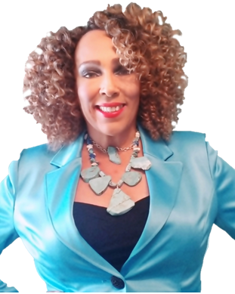
“There are several books written about domestic violence, sexual abuse or bullying. I AM A SURVIVOR stands out from other publications because it is a collaboration book comprised of several women, who share their experiences with several forms of abuse and share how they individually, found the strength to move forward. As we tell our stories, we heal ourselves. As other’s read our stories, we pray they too can find the healing they deserve.” Author, Michele Lee Evans

About M.L.E. Enterprises
M.L.E Enterprises is a company founded by entrepreneur Michele Lee Evans, as an “umbrella company” for the many services and products she offers. M.L.E offers a direct link to Mileeva Designs, Mrs. Evans jewelry company, The F.A.A.B Foundation, her anti-abuse and anti-bullying non-profit, Mileeva Speaks, her radio podcast and her creative consulting services. M.L.E helps authors and inspiring authors to write and create their books, design websites, create marketing tools to make their books successful and assist with booking speaking engagements. M.L.E also offers creative consultation for entrepreneurs, networking solutions and advertising. For more information on services and products provided by M.L.E Enterprises, please visit:
www.mle-enterprises.com

